INVOICE

Issued by: “ALL IN LOG” MMC Date
TIN: 1506805111
___________________________________________________________
Account: AZ06AIIB401500H9784261552218
TIN: 1506805111
Bank: KapitalBank ASC, Bravo 3 branch
SWIFT: AIIBAZ2XXXX
Bank TIN: 9900003611
Code: 201296
Correspondent Bank: Raiffeisen Bank International AG, Vienna Austria; SWIFT: RZBAATWW; Correspondent account: 001-55.075.527
________________________________________________________________________________
Buyer (Payer):
TIN:

No. | Description of work | Quantity  (units) | Total amount  (EUR)
1
Total
VAT 18%
Grand total
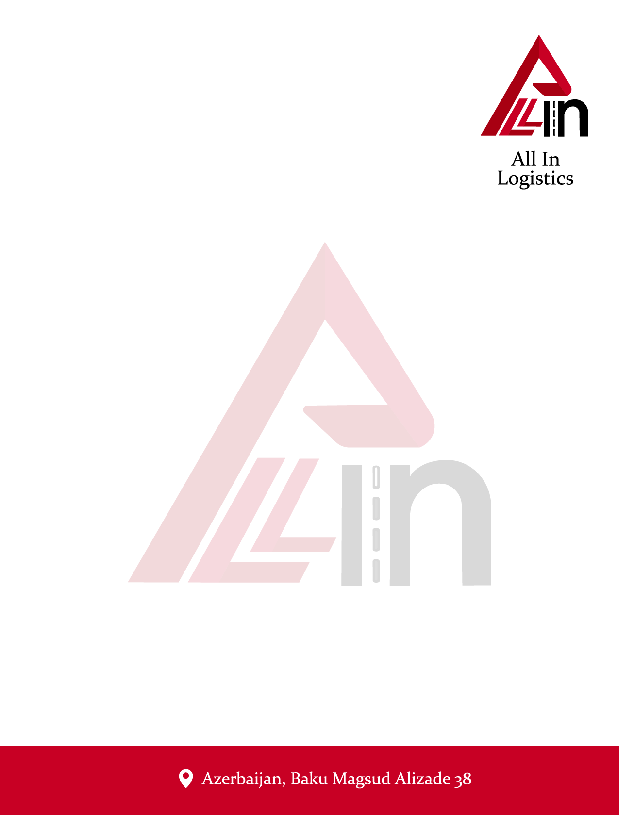

Director: Ələkbərov Vüsal

